Chapter 10, Solution 79.

For the op amp circuit in Fig. 10.122, obtain v_{o}(t).

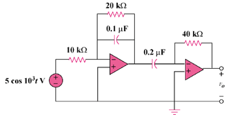

Figure 10.122
For Prob. 10.79.

Solution

Consider the circuit shown below.

+

10 k

+

+

V_{o}

40 k

-j10 k

-j5 k

V₁

V_{s} = 0.50 V
+

20 k

Since each stage is an inverter, we apply to each stage.
(1)
and
(2)

From (1) and (2),
Therefore, 3.578cos(1000t + 26.56) V

